Issue | What have I done | Where it is (Page)

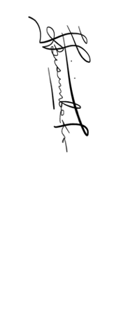
Student Name: Remmy Bisimbeko Supervisor: Dr. Daphne N. Bitalo
Signature: Signature:
Date: August, 2026 Date: August, 2026

